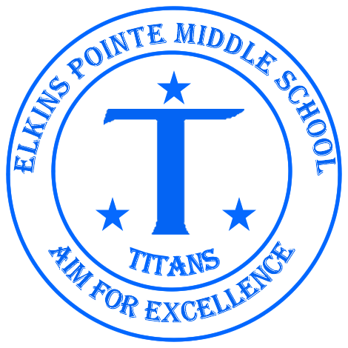

Mrs. Allison Goodrich Ms. Sharia Osborne
770-852-0076

goodricha@fultonschools.org osbornes@fultonschools.org

Welcome to 8th Grade Physical Science and the 2017-2018 school year! I am thrilled that your son/daughter will be a part of my class. I am committed to making this an exciting, challenging, and positive learning experience. This year will be filled with a multitude of lessons, activities, and projects that will require students to experiment and manipulate science equipment as well as communicate results from experimentation and sharpen and expand science process skills. There will also be a substantial emphasis on advanced research skills, problem solving, critical thinking and creative thinking. This class is designed to provide students with an understanding of the basic principles of Physical Science and their direct application to our world. In this course, students will be provided with more opportunities for in-depth research, independent study and advanced communication skills.

Textbook
Students will be provided a hardcopy textbook for in class use ONLY. All textbooks are available online for out of class use. The online information for the Physical Science textbook is:

Computer website: my.hrw.com
Login in: Username: astudents795 Password: s9v4x

Course Outline for the Year
Topics to be covered this year include the following (not necessarily in this order):
Fall Semester: Spring Semester:
Lab Safety Motion
Matter Electricity
Chemistry Magnetism
Energy Light, Color, Mirrors
Heat Sound
Force

Course Outcome Expectations:
At the end of this course students should be able to:
- Use appropriate scientific tools to observe, record, organize, analyze, interpret, write, and present the results of scientific investigations clearly and accurately.
- Examine the scientific view of the nature of matter including its properties, types, forms, movement, and changes.
- Recognize that there are more than 100 elements on the Periodic Table grouped according to their properties.
- Explain the forms, transformation, transfer and conservation of energy.
- Demonstrate and determine the relationships between forces, mass and motion of objects.
- Demonstrate the effects of simple machines on work.
- Identify the characteristics of waves, including mechanical and electromagnetic waves, and describe their behavior in different mediums/surfaces.
- Recognize that every object exerts gravitational force on other objects proportional to their respective masses and relative distances.
- Demonstrate the advantages and disadvantages of series and parallel circuits relative to electrical energy transfer.
- Investigate and explain that electric circuits and magnets can exert mutual forces on each other and describe the application of these forces.

Policies, Procedures and Requirements:
- Labs and hands-on activities are a required part of science. When involved with such lessons, students must follow directions carefully, wait for instructions and behave in an appropriate manner. Students who do not follow these guidelines will not be allowed to participate and will receive an alternative assignment.
- Special projects will be assigned periodically. These projects will be assessed on grading criteria given when the assignment is made (rubric). Advance notice, due date, timeline, and specific directions will be given with every project.
- Make up work for any absence is the responsibility of the student. Make up work will be placed in the “Absent” bucket. A student has the same number of days as the number of days absent to make up all assignments. Make up of a test or quiz will need to be scheduled. The absent student is responsible for making these arrangements with Mrs. Goodrich. Failure to make up assignments, tests or quizzes will result in a zero and thereby become detrimental to the student’s semester average.
Absences in class have a unique drawback in that much of our class work is done in the form of discussion and writing. It is not possible to recapture those discussions which deal with subjects for writing and answers to test questions. Please consider this when scheduling appointments.
- Assignments that are not presented on the due date are considered late and will incur a penalty. Assignments may be turned in 1 day late for 50% credit and will not be accepted after that. Major projects will receive a ten-point deduction each day it is late.
- Regular attendance is very important to your child’s success. Please make sure that absences are documented with a valid excuse.
- Students are required to come prepared for class with their science notebook, paper, and a writing utensil EVERYDAY

Recovery Policy:
- Only tests are eligible for recovery
- Only students scoring lower than an 80% on original test are eligible as long as they complete the following steps:
  - Student must make test corrections
  - Student must attend at least one help session
  - Student must complete recovery assignment as needed
  - Student must complete the process within 1 week of receiving the grade
- 80% is the highest grade student is able to receive after recovery.

Academic Honesty
All students are expected to exemplify academic honesty. “Academic Honesty” means performing all academic work without plagiarism, cheating, lying, tampering, stealing, giving or receiving unauthorized assistance from any other person, or using any source of information that is not common knowledge without properly acknowledging the source.

Grading Rules:
The following is a percentage breakdown of how grades will be calculated. Four and half week interim and nine week report cards will be issued.
Tests/Projects 40%
Major Labs/Reports 30%
Quizzes 20%
Classwork 10%

Communication:
Open communication between parents, teachers and students is essential for a successful year. E-mail is the most effective way to reach me; goodricha@fultonschools.org

Parent-teacher conferences are also available upon request.

Please make sure to check my blog for updates, as well.
allisongoodrich.com

Also, please join our Remind! I will send out updates throughout the year. https://www.remind.com/join/goodrichs

I am so excited about the successes and accomplishments that this school year has in store! Please do not hesitate to contact me. I will get back to you as soon as I can.

Always Appreciative,

- Goodrich
MATERIALS LIST FOR 8TH GRADE PHYSICAL SCIENCE

- Titan Binder
- Pens and Pencils
- Flash/Jump drive
- Highlighters
- Loose leaf paper

Please sign below indicating that you have read the syllabus and return this section to your teacher by Monday, August 14th. Keep the syllabus for future reference.

Student Printed Name: _________________________________________________________

Students Signature: ____________________________________________________________

Parent Signature: ______________________________________________________________

Parent Phone Number(s): _______________________________________________________

Parent E-mail Address: __________________________________________________________

From time to time during the school year we like to show videos and parts of videos to supplement and extend the curriculum in our subject areas. Students are always given a specific viewing purpose and have an academic task to complete either during or following the video.

The purpose of this communication is to allow you to give permission for your child to view any PG or PG-13 video we might show for the rest of the year. Please indicate your preference below and have your child return this form to us by August 12th. If you have any questions, feel free to contact us.

__ I give permission for my child to watch any PG & PG-13 rated movies this school year at EPMS.

__ I do not give permission for my child to watch any PG or PG-13 rated movies this school year at EPMS.

Student Name __________________________________________________
(please print)

Parent Signature __________________________________________________

